NEOC Website & Admin Panel — Specification and Requirements
Oct 24, 2026 · @Gingitech
This specification defines everything needed to build, launch and run the NEOC Technology public website and its content-management admin panel. A clickable prototype already exists and serves as the visual and functional reference.

1. Document control
Item | Detail
Document | Website & Admin Panel Specification and Requirements
Version | 1.0 (initial draft)
Client | NEOC TECHNOLOGY COMPANY LIMITED, Reg. No 203431848
Client contact | Joniphace Muyama Philmon, Managing Director
Reference | Company profile (PDF) and the clickable HTML prototype
Audience | Developers, designer, project manager, client approvers
Readers should use this document to estimate cost, plan the build and test the finished product. Each requirement has an ID (for example FR-PUB-03) so it can be traced from design through testing.

2. Project overview
NEOC is a new company (established May 2026) in Kijitonyama, Dar es Salaam. It needs a credible web presence that turns visitors from telecoms, government, banks and SMEs into enquiries, and that staff can update without a developer.
Objectives
- Present the company, its 7 service lines and its credentials clearly to corporate and public-sector buyers.
- Capture enquiries through a contact form and deliver them to staff the same day.
- Let non-technical staff edit all site content through a secure admin panel.
- Load fast on mobile networks common in Tanzania and work well on phones.
- Be ready for tender submissions, where procurement officers check a company's website.
Audiences
Audience | What they need from the site
Procurement officers (government, banks, telecoms) | Registration number, TIN, address, services, contact
IT and facilities managers | Detailed capabilities per service, delivery approach
SME owners | Simple explanation of services, quick way to call or message
NEOC staff (admin) | Easy content editing, enquiry inbox
Success measures (first 6 months after launch)
- Every page loads in under 3 seconds on a 4G connection.
- At least 20 qualified enquiries received through the form.
- Staff update content themselves, with no developer needed for text changes.
- The site appears on page 1 of Google for "NEOC Technology" and "IT infrastructure company Dar es Salaam".

3. Scope
Phase 1 delivers a 4-page public website, a protected admin panel and an enquiry inbox. Anything not listed under "In scope" needs a change request.
In scope
- Public pages: Home, About, Services, Projects, Contact, plus Privacy Policy and a 404 page.
- Admin panel: login, dashboard, content editors for every section, services manager, projects manager with photo upload and delete, enquiry inbox, user management, settings.
- Email notification to NEOC when a new enquiry arrives.
- Responsive design for phones, tablets and desktops; light and dark display modes.
- Basic SEO setup, Google Analytics (or a privacy-friendly alternative), sitemap.xml and robots.txt.
- Domain, hosting, SSL certificate and business email setup support.
- Training session (2 hours) and a short admin user guide.
Out of scope (phase 2 candidates)
- Swahili language version of the site.
- Detailed case studies with client testimonials and measured results (the photo portfolio itself is in scope).
- Online quotation calculator or e-commerce for hardware.
- Client portal for support tickets.
- Blog / news section.
- Live chat or WhatsApp Business API integration (a simple WhatsApp click-to-chat link is in scope).
Assumptions
- NEOC supplies the logo in vector format, final text approvals and any photos.
- Content starts from the company profile; NEOC approves wording before launch.
- Hosting is a managed VPS or shared hosting with PHP/Node support, paid by NEOC.
- The domain (for example neoctech.co.tz) is registered through a .tz registrar under NEOC's name.

4. Public website: sitemap and pages
The public site has five main pages reachable from a sticky header on every page, plus three utility pages. Every page shares the same header, footer and contact details, all editable from the admin panel.
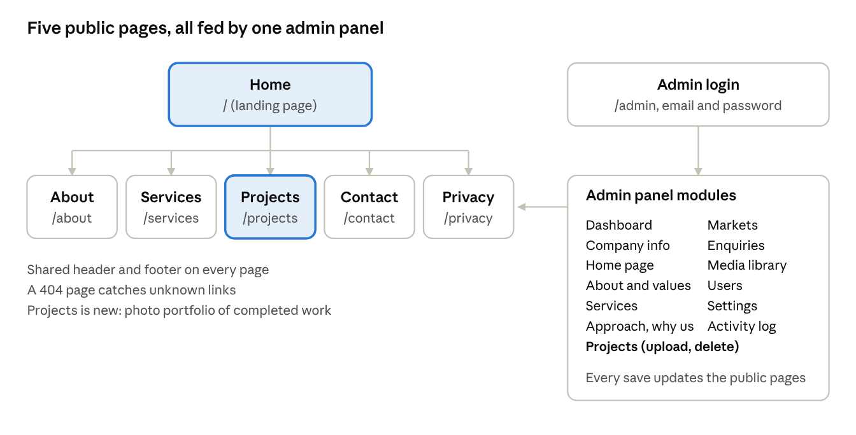
sitemap · 5 public pages + privacy, admin with 13 modules
The admin panel is the only way content changes; visitors never see it.
Header (all pages): logo linking to Home; links to Home, About, Services, Projects, Contact; a "Request a quote" button; a Menu button that opens the links on screens under 820 px wide.
Footer (all pages): company name and tagline, physical and postal address, both phone numbers, email, quick links, Registration No and TIN, copyright year (automatic), a strip in the 12 fibre colours.

4.1 Home
Block | Content | Notes
Hero | Eyebrow label, headline, supporting text, two buttons (Request a quote, Explore services) | Dark band with animated fibre lines; animation stops if the visitor prefers reduced motion
Company record card | Name, location, Reg. No, TIN, year established, phone | Builds trust for procurement officers
Services overview | One card per service: fibre colour tag, title, summary, capability count | Cards link to the Services page
Delivery approach | 6 stages from Requirements Assessment to Maintenance & Support | Numbered, in order
Why NEOC | 6 reasons with short descriptions
Sectors served | 9 target markets as chips
Call to action | Short prompt and "Talk to our team" button | Links to Contact
Recent work | The 3 newest projects as photo cards, plus a link to all projects | Hidden until at least one project exists

4.2 About
Block | Content
Intro | Tagline as page heading, 3 paragraphs about the company
Vision and Mission | Two statements side by side
Core values | 7 values, each with a short description
Corporate information | Table: name, country, Reg. No, TIN, physical and postal address, phones, email, Managing Director, year established
Certifications | Hidden until NEOC holds certifications; then listed with issuer and expiry

4.3 Services
Shows all service lines as cards. Each card has a fibre colour tag (F01 Blue, F02 Orange, and so on), title, summary and the full list of capabilities. Each card has an anchor so links like /services#cctv open at that service. A note states that equipment is subject to specifications, availability, warranty and agreed procurement terms.
The 7 launch services are:
- IT Infrastructure
- Networking & Telecommunications
- Data Centre & Enterprise Solutions
- IT Consultancy & Technical Support
- Electrical Equipment & Generators
- CCTV & Electric Fence
- Hardware Supply & Procurement

4.4 Projects (portfolio)
Shows completed jobs as photo cards so buyers can see real work before they call. New in this version of the specification.
Block | Content | Notes
Intro | Heading and one sentence about the work shown | Editable in admin
Service filter | Chips: All (with count), then one chip per service that has projects | Only services with at least one project appear
Project grid | One card per project: cover photo, service tag with fibre colour, title, client, location, month completed, photo count | Newest first; 3 columns on desktop, 1 on phones
Project viewer | Opens on click: large photo with previous/next arrows, thumbnails, title, client, location, completed date, description | Closes with the Close button, the Esc key or a click outside; arrow keys change photos
Empty state | "No projects have been published yet" message | Shown until the first project is added
Call to action | "Want results like these for your site?" and a Request a quote button | Links to Contact
The Home page also shows the 3 newest projects in a "Recent work" block, with a link to the Projects page. The block is hidden while there are no projects.

4.5 Contact
Block | Content
Contact details | Phone 1, phone 2, email, office address, postal address, each with a Copy button; phone numbers also as tap-to-call links on mobile
WhatsApp | Click-to-chat button to +255 629 101 982
Map | Static map image or a link to Google Maps for Kijitonyama Mabatini Road
Enquiry form | Full name*, Organisation, Email, Phone, Service needed (dropdown from the services list), Message*; at least one of Email or Phone required
Confirmation | On-page thank-you message naming the sender; error message with phone and email if sending fails

4.6 Utility pages
- Privacy Policy: what the form collects, why, how long it is kept, how to ask for deletion (aligned with Tanzania's Personal Data Protection Act, 2022).
- 404 page: short message and links back to Home and Services.
- Thank-you state: shown in place on the Contact page, no separate page needed.

5. Admin panel modules
The admin panel lives at /admin, is reachable only after login, and controls every word, list and contact detail shown on the public site. It has a left sidebar on desktop and a scrollable tab bar on phones.
Module | What staff can do | Key rules
Login | Sign in with email and password; reset a forgotten password by email | Lock the account for 15 minutes after 5 failed tries; optional 2-step code by email or authenticator app
Dashboard | See counts of services, total and unread enquiries, sectors; last publish date; latest 3 enquiries; shortcuts | Read-only summary
Company info | Edit company name, tagline, phones, email, physical and postal address, Reg. No, TIN, Managing Director, year established, country | Email and phone formats validated
Home page | Edit hero eyebrow, headline, supporting text and the quality statement | Headline limited to 90 characters
About & values | Edit about text, vision, mission; add, edit, reorder and remove core values | Blank line separates paragraphs
Services | Add, edit, reorder, hide or remove services; set title, summary, fibre colour, capabilities (one per line), optional image | At least 1 service must stay visible
Approach & why us | Add, edit, reorder and remove delivery stages and reasons | Stages display in the saved order
Markets | Edit the list of sectors served, one per line
Enquiries (inbox) | Read enquiries newest first; filter by status and service; mark read or unread; add an internal note; mark as Replied; delete; export to CSV | Delete asks for confirmation on screen
Media library | Upload logo, favicon, service images; see size and where each is used | JPG, PNG, WebP, SVG; max 2 MB each; images resized automatically
Users | Invite staff, assign a role, deactivate accounts | Only Super Admin sees this module
Settings | SEO title and description per page, social links, WhatsApp number, notification email address, Google Analytics ID, maintenance mode
Activity log | See who changed what and when | Kept for 12 months
Projects | Add a completed project with title, client, location, service, month completed, description and up to 8 photos (choose or drag and drop); see all published projects; view one; delete a project together with its photos | Title and at least 1 photo required; photos resized to 1800 px max and compressed to JPEG before upload; delete asks for confirmation on screen and removes the photo files too
Editing behaviour (all content modules)
- Changes stay as a draft until staff press Save & publish; a bar at the bottom shows "Unsaved changes" while a draft exists.
- Discard restores the last published version; Restore defaults reloads the original company-profile text after an on-screen confirmation.
- Preview opens the public page with the draft applied, visible only to the logged-in user.
- The last 20 published versions are kept so any of them can be restored.

6. Functional requirements
34 requirements, 22 of them Must. Must items are required for launch; Should items are expected in phase 1 but can slip to the first update; Could items are optional. Change a priority with the dropdown.
ID | Requirement | Priority
FR-PUB-01 | All public content (text, lists, contacts) is loaded from the database, not hard-coded | Must
FR-PUB-02 | Header navigation highlights the current page and collapses into a menu under 820 px | Must
FR-PUB-03 | Services page shows only services marked visible, in the order set in admin | Must
FR-PUB-04 | Contact form validates required fields in the browser and on the server | Must
FR-PUB-05 | Contact form is protected against spam (honeypot field + rate limit of 5 per hour per IP, or reCAPTCHA/Turnstile) | Must
FR-PUB-06 | Phone numbers are tap-to-call and email is tap-to-mail on mobile | Should
FR-PUB-07 | A published change in admin appears on the public site within 60 seconds | Must
FR-PUB-08 | WhatsApp click-to-chat button on Contact and as a floating button on mobile | Should
FR-ENQ-01 | Each enquiry is saved with date, time, sender details, service and message | Must
FR-ENQ-02 | A notification email goes to the address set in Settings within 2 minutes of submission | Must
FR-ENQ-03 | The sender receives an automatic acknowledgement email when they gave an email address | Must
FR-ENQ-04 | Enquiries export to CSV with all fields | Should
FR-ADM-01 | Admin pages require login; sessions expire after 60 minutes of inactivity | Must
FR-ADM-02 | Staff can edit every field listed in section 5 and publish in one action | Must
FR-ADM-03 | Lists (services, values, stages, reasons) support add, edit, reorder and remove | Must
FR-ADM-04 | Unsaved changes are flagged and the user is warned before leaving the page | Must
FR-ADM-05 | Version history keeps the last 20 publishes and can restore any of them | Should
FR-ADM-06 | Draft preview shows the public page with unpublished changes to the logged-in user only | Should
FR-ADM-07 | Admin panel available in English and Swahili | Could
FR-SEC-01 | Passwords stored with bcrypt or Argon2; never stored or emailed in plain text | Must
FR-SEC-02 | Role-based access as defined in section 11 is enforced on the server for every action | Must
FR-SEC-03 | Account lock for 15 minutes after 5 failed logins | Must
FR-SEC-04 | Optional 2-step verification for admin accounts | Should
FR-SEC-05 | Every content change and login is written to the activity log | Should
FR-OPS-01 | Daily automatic backup of database and uploads, kept for 30 days, stored off the server | Must
FR-OPS-02 | HTTPS everywhere; HTTP redirects to HTTPS | Must
FR-OPS-03 | Maintenance mode shows a holding page to visitors while admins can still log in | Should
FR-OPS-04 | Uptime monitoring alerts NEOC by email when the site is down for 5 minutes | Should
FR-OPS-05 | Monthly visitor and enquiry summary emailed to the Managing Director | Could
Projects portfolio requirements
ID | Requirement | Priority
FR-PRJ-01 | Public Projects page lists published projects newest first, filterable by service | Must
FR-PRJ-02 | Clicking a project opens a viewer with all its photos and details | Must
FR-PRJ-03 | Editors add a project with title, details and 1 to 8 photos; photos are resized and compressed before upload | Must
FR-PRJ-04 | Editors delete a project after an on-screen confirmation; its photo files are removed from storage too | Must
FR-PRJ-05 | Home page shows the 3 newest projects when any exist | Should

7. Non-functional requirements
The site must be fast on mobile data, secure enough for a company that sells information-security services, and readable by everyone.
Area | Requirement | How it is checked
Performance | Largest Contentful Paint under 2.5 s and total page weight under 1.5 MB on Home | Google PageSpeed Insights, mobile profile, score 85 or higher
Performance | Images served as WebP, lazy-loaded below the fold, fonts limited to 3 families | Lighthouse audit
Responsiveness | Works from 360 px phone width to 1920 px desktop with no sideways scrolling | Manual test on Android, iPhone, tablet, desktop
Browsers | Latest 2 versions of Chrome, Safari, Firefox, Edge, and Samsung Internet | Cross-browser test checklist
Accessibility | WCAG 2.1 AA: contrast 4.5:1 for text, keyboard navigation, visible focus, form labels, alt text | axe DevTools scan with zero serious issues
Security | OWASP Top 10 covered: input validation, output escaping, CSRF tokens, parameterised queries, secure cookies (HttpOnly, Secure, SameSite) | Security checklist and a vulnerability scan before launch
Security | Security headers: Content-Security-Policy, HSTS, X-Frame-Options, Referrer-Policy | securityheaders.com grade A
Privacy | Personal data from the form handled under the Personal Data Protection Act, 2022 (Tanzania); enquiries older than 24 months deleted automatically | Privacy policy published; retention job tested
Availability | 99.5% monthly uptime | Uptime monitor report
SEO | Unique title and meta description per page, Open Graph tags, structured data (Organization, LocalBusiness), sitemap.xml, clean URLs | Google Search Console with no errors
Maintainability | Code in a Git repository owned by NEOC; README with setup steps; environment variables for secrets | Handover review
Theming | Light and dark display modes follow the visitor's device setting | Visual check in both modes

8. Data model
Ten tables (plus a link table for project photos) hold all site data. Single-value content (company details, hero text, vision) sits in key–value settings; lists that staff reorder get their own tables with a sort_order column.
Table | Main fields | Notes
users | id, full_name, email (unique), password_hash, role, is_active, two_factor_secret, last_login_at, created_at | Roles: super_admin, editor, viewer
site_settings | key (unique), value (text/JSON), updated_by, updated_at | Keys such as company.name, company.tin, hero.headline, about, vision, mission, quality, seo.home.title
services | id, slug, title, summary, fiber_color (1–12), image_id, is_visible, sort_order, updated_at | Slug used for /services#slug
service_items | id, service_id, text, sort_order | Capabilities under a service
list_items | id, list_type (value, approach, why, market), title, description, sort_order | One table for the four simple lists
enquiries | id, name, organisation, email, phone, service_id, message, status (new, read, replied), internal_note, ip_hash, created_at | IP stored as a hash only, for rate limiting
media | id, filename, path, mime_type, size_bytes, width, height, alt_text, uploaded_by, created_at
content_versions | id, snapshot (JSON of all content), published_by, published_at | Last 20 kept
activity_log | id, user_id, action, entity, entity_id, details (JSON), created_at | Kept 12 months
projects + project_images | projects: id, title, client, location, service_id, completed_month, description, is_visible, created_by, created_at · project_images: id, project_id, media_id, sort_order | Deleting a project deletes its image rows and the media files
The prototype stores the same content as one JSON document. That shape is a valid alternative for a small site using a document database such as Firestore or MongoDB:
{
"company": {"name": "…", "tagline": "…", "phone1": "…", "phone2": "…", "email": "…", "address": "…", "postal": "…", "reg": "…", "tin": "…", "md": "…", "established": "…"},
"hero": {"eyebrow": "…", "headline": "…", "sub": "…"},
"about": "…", "vision": "…", "mission": "…", "quality": "…",
"values": [{"t": "Integrity", "d": "…"}],
"services": [{"title": "…", "fiber": 0, "summary": "…", "items": ["…"]}],
"approach": [{"t": "…", "d": "…"}],
"why": [{"t": "…", "d": "…"}],
"markets": ["…"],
"updatedAt": 1792846949000
}

9. Technical architecture
The recommended build is a server-rendered website with a separate admin area, both served by one application and one database. This keeps hosting cheap, pages fast and search engines happy.
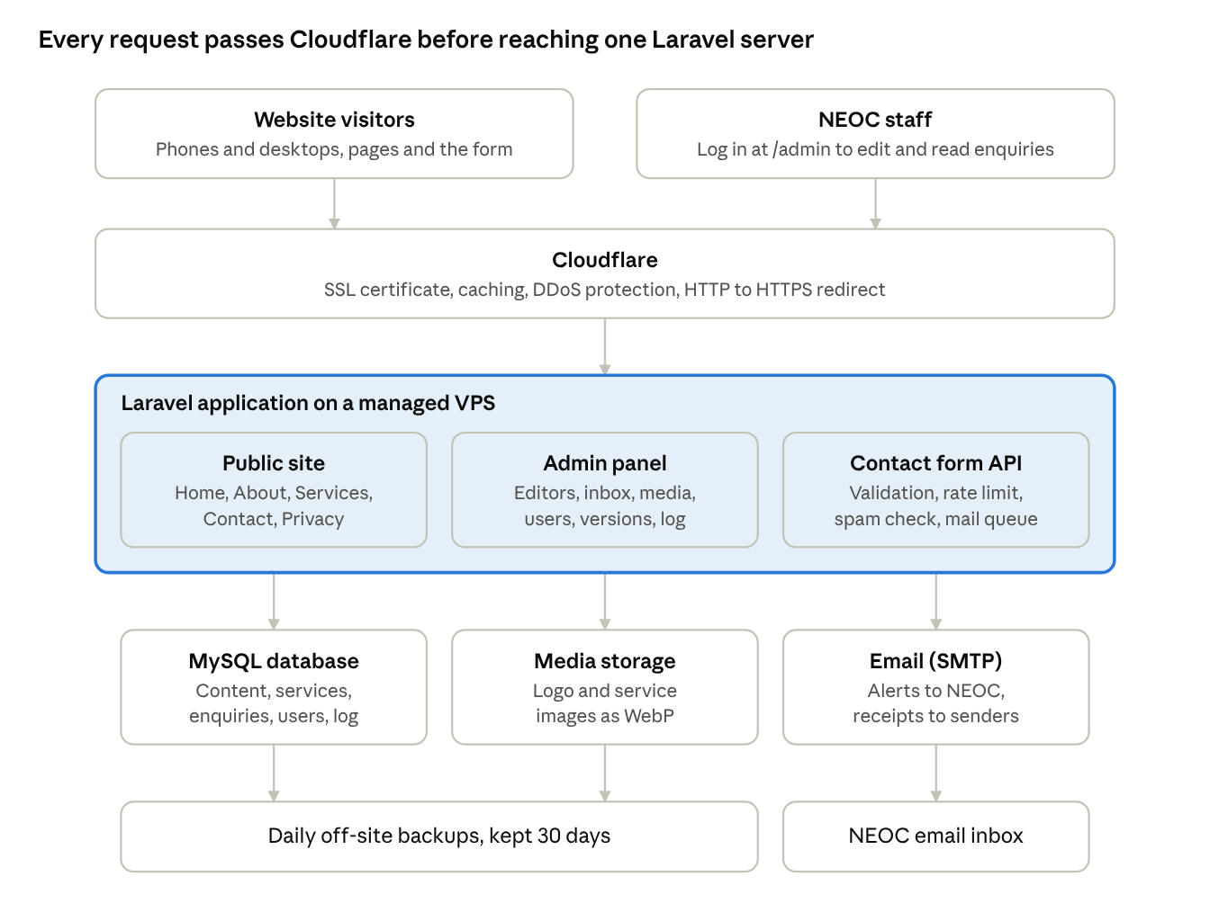
system architecture · Option A
One server runs the public site, the admin panel and the form API; the database and media are backed up off-site every day.
Recommended stack (Option A: Laravel)
Layer | Choice | Why
Backend | Laravel 11 (PHP 8.3) | Mature, widely known by developers in Tanzania, built-in auth, validation, mail and queues
Public pages | Blade templates, server-rendered, plus a little Alpine.js | Fast first load, full SEO
Admin panel | Filament 3 (or Laravel + Livewire custom screens) | Ready-made CRUD, roles, file uploads
Database | MySQL 8 or MariaDB 10.11 | Standard on Tanzanian hosts
Email | SMTP through the domain's business email, or a transactional service (Brevo, Mailgun) | Enquiry notifications
Hosting | Managed VPS (2 vCPU, 4 GB RAM) or quality cPanel hosting with SSH | Local providers or a nearby cloud region (e.g. Johannesburg, Frankfurt)
CDN and security | Cloudflare free plan in front of the site | Caching, DDoS protection, SSL
Alternative (Option B: JavaScript): Next.js 14 for the public site, a headless CMS (Strapi or Payload) for admin, PostgreSQL database, hosted on a VPS or Vercel + a managed database. Choose B only if the developer team works mainly in JavaScript.
API endpoints (admin, JSON, all require an authenticated session and CSRF token)
Method | Path | Purpose | Role
POST | /api/auth/login | Sign in | Public
POST | /api/auth/logout | Sign out | Any signed in
GET | /api/content | Read all site content | Any signed in
PUT | /api/content | Save and publish content | Editor, Super Admin
GET | /api/content/versions | List published versions | Editor, Super Admin
POST | /api/content/versions/{id}/restore | Restore a version | Super Admin
GET, POST | /api/services | List, create services | Editor, Super Admin
PUT, DELETE | /api/services/{id} | Update, remove a service | Editor, Super Admin
PATCH | /api/services/order | Save new order | Editor, Super Admin
POST | /api/enquiries | Submit the public contact form | Public, rate-limited
GET | /api/enquiries | List enquiries with filters | Any signed in
PATCH | /api/enquiries/{id} | Change status, add note | Editor, Super Admin
DELETE | /api/enquiries/{id} | Delete an enquiry | Super Admin
GET | /api/enquiries/export | Download CSV | Editor, Super Admin
POST | /api/media | Upload a file | Editor, Super Admin
GET, POST, PATCH | /api/users | Manage staff accounts | Super Admin
GET | /api/projects | List projects (public list shows visible ones only) | Public
POST | /api/projects | Create a project with its photos (multipart upload) | Editor, Super Admin
DELETE | /api/projects/{id} | Delete a project and its photo files | Editor, Super Admin
Environments: local development, a staging site (staging.neoctech.co.tz, password-protected) for client review, and production. Deployments go from the Git main branch to staging first, then to production after sign-off.

10. Design system
The look comes from the company's world of cables and network rooms: a deep teal accent for connectivity, a dark "network room" hero, and service colours taken from the real 12-fibre colour code (TIA-598) that technicians use to label strands.
Colours
Token | Light mode | Dark mode | Use
Background | #F3F6F5 | #0A1214 | Page background
Surface | #FFFFFF | #101B1E | Cards, header, forms
Ink | #0D1B1E | #E5EEEB | Main text
Muted | #4D6166 | #93A7A5 | Secondary text
Line | #D2DDDA | #24373B | Borders, dividers
Accent (teal) | #0A7C72 | #3CC2B2 | Buttons, links, active states
Signal (amber) | #D97F15 | #F0A44B | Unread badges, highlights
Hero band | #081215 | #081215 | Hero and footer, same in both modes
Fibre colour code for services (strand number · name · hex): 1 Blue #1F6FD1 · 2 Orange #F08A24 · 3 Green #2E9E4F · 4 Brown #8A5A2B · 5 Slate #7D8A93 · 6 White #E9EDEE · 7 Red #D63A3A · 8 Black #1C1C1C · 9 Yellow #E5C12A · 10 Violet #7E4BC4 · 11 Rose #E98AA8 · 12 Aqua #2EC4C4. Each service is tagged F01, F02… with its colour dot.
Typography
Role | Font | Sizes
Display (headings, logo) | Archivo, expanded width, weight 700–800 | H1 34–64 px (fluid), H2 28–42 px, H3 18–22 px
Body | IBM Plex Sans 400/500/600 | 16 px, line height 1.6
Data and labels | IBM Plex Mono 400/500 | 11–13 px, uppercase labels with letter spacing
All fonts are free on Google Fonts and should be self-hosted in production for speed.
Components: buttons (primary, ghost, danger, small), service "port" cards, stat tiles, chips, form fields with focus ring, info table, save bar, toast message, sidebar navigation, message card with unread stripe. Corner radius 8–10 px; spacing on an 8 px grid; content width up to 1180 px; side margins at least 16 px.
Logo: the prototype uses a placeholder mark (an N formed by a fibre path with an amber signal dot). Replace it with NEOC's official logo if one exists.

11. User roles and permissions
Three admin roles cover NEOC's needs; the Managing Director holds Super Admin. Permissions are checked on the server for every request, not only hidden in the interface.
Action | Super Admin | Editor | Viewer
View dashboard and content | Yes | Yes | Yes
Edit and publish content, services, lists | Yes | Yes | No
Upload and remove media | Yes | Yes | No
Read enquiries | Yes | Yes | Yes
Change enquiry status, add notes, export CSV | Yes | Yes | No
Delete enquiries | Yes | No | No
Restore an older version | Yes | No | No
Manage users and roles | Yes | No | No
Change settings (SEO, notification email, maintenance mode) | Yes | No | No
View activity log | Yes | No | No
Public visitors have no account. They can read every public page and submit the contact form, limited to 5 submissions per hour from one network.

12. Testing and acceptance
NEOC accepts the project when every Must requirement passes on the staging site and the checklist below is signed. Defects found in acceptance are fixed within 5 working days.
Test types
- Functional: each FR in section 6 has at least one test case with steps and expected result.
- Cross-device: Android phone (Chrome), iPhone (Safari), tablet, Windows and Mac desktop.
- Performance: PageSpeed mobile score 85+ on Home, About, Services, Contact.
- Security: login lockout, role checks by direct URL, CSRF, XSS in every text field, file-upload type checks, vulnerability scan.
- Accessibility: keyboard-only walk-through and axe scan.
- User acceptance: NEOC staff complete the tasks below without help.
Acceptance checklist
- ☐ Staff change the hero headline and see it on the live site within 60 seconds
- ☐ Staff add a new service with 4 capabilities, move it to position 2, and it shows correctly
- ☐ Staff hide a service and it disappears from Home and Services
- ☐ A test enquiry arrives in the inbox and as an email within 2 minutes
- ☐ The sender receives an acknowledgement email
- ☐ Enquiries export to CSV and open correctly in Excel
- ☐ An Editor cannot open Users or Settings, even by typing the URL
- ☐ Five wrong passwords lock the account for 15 minutes
- ☐ A version from yesterday can be restored by the Super Admin
- ☐ All pages pass PageSpeed and accessibility targets
- ☐ Backups run and one restore has been tested
- ☐ Privacy Policy is published and linked from the form
Projects checklist
- ☐ Staff add a project with 5 photos; it appears first on the Projects page and in Recent work on Home
- ☐ The service filter shows only that project when its service chip is chosen
- ☐ The project viewer opens, changes photos with arrows and keys, and closes with Esc
- ☐ Staff delete the project; it disappears from both pages and its photo files are gone from storage
- ☐ A 12 MB phone photo uploads successfully after automatic resizing

13. Delivery plan and maintenance
The build takes about 7 weeks from kick-off to launch for one full-stack developer and a part-time designer, assuming NEOC approves each stage within 3 working days.
- Week 1 · Discovery and content. Kick-off meeting, confirm scope, collect logo, photos and final text, register domain and hosting. Deliverable: signed scope and content pack.
- Week 2 · Design. Finalise design from the prototype; desktop and mobile mock-ups for 4 pages and the admin. Deliverable: approved designs.
- Weeks 3–4 · Build the public site and database. Pages, content loading, contact form, email notifications. Deliverable: public site on staging.
- Weeks 5–6 · Build the admin panel. Login, all editors, inbox, media, users, settings, version history, activity log. Deliverable: full system on staging.
- Week 7 · Testing, training and launch. Test plan run, fixes, staff training (2 hours), go-live, Search Console submission. Deliverable: live site, admin guide, source code and credentials handed over.
- Weeks 8–11 · Warranty. 30 days of free bug fixing after launch.
Handover deliverables
- Source code in a Git repository owned by NEOC
- Database schema and a seeded copy with launch content
- Admin user guide (PDF, English with key screens in Swahili)
- Hosting, domain, email and Cloudflare credentials in a password manager shared with the Managing Director
- Backup and restore instructions
Ongoing maintenance (monthly retainer, optional)
- Security and framework updates, backup checks, uptime monitoring
- Up to 2 hours of small changes per month
- Monthly report: uptime, visitors, enquiries, updates applied
- Annual renewal reminders for domain, hosting and SSL

14. Inputs from NEOC and open questions
The build can start once the first five items below are supplied.
Inputs needed
- ☐ Official logo (SVG or high-resolution PNG) and any brand colours
- ☐ Preferred domain name (for example neoctech.co.tz or neoc.co.tz)
- ☐ Email address that should receive enquiries (a business address on the domain is recommended over Gmail)
- ☐ Approval of all page text taken from the company profile
- ☐ Names, emails and roles of the staff who will use the admin panel
- ☐ Photos of team, equipment or completed sites (optional, improves trust)
- ☐ Exact office location pin for the map
Open questions
- Is a Swahili version of the public site needed at launch or in phase 2?
- Should the company profile PDF be downloadable from the About page?
- The company profile skips section 5.3; is a service missing there?
- Which certifications or supplier partnerships (for example Cisco, Huawei, Dell) can be shown?
- Should enquiries also be sent to WhatsApp or SMS?
- Is there a budget ceiling that should shape the choice between Option A and Option B?

Reference
The clickable prototype (website and admin panel) and its downloadable HTML file accompany this document. Behaviour shown in the prototype is the reference wherever this document is silent.

